Day 37

Statement interface

The Statement interface provides methods to execute queries with the database. The statement interface is a factory of ResultSet i.e. it provides factory method to get the object of ResultSet.
Commonly used methods of Statement interface:

The important methods of Statement interface are as follows:
1) public ResultSet executeQuery(String sql): is used to execute SELECT query. It returns the object of ResultSet.
2) public int executeUpdate(String sql): is used to execute specified query, it may be create, drop, insert, update, delete etc.
3) public boolean execute(String sql): is used to execute queries that may return multiple results.
4) public int[] executeBatch(): is used to execute batch of commands.

import java.sql.*;
class FetchRecord{
public static void main(String args[])throws Exception{
Class.forName("oracle.jdbc.driver.OracleDriver");
Connection con=DriverManager.getConnection("jdbc:oracle:thin:@localhost:1521:xe","system","oracle");
Statement stmt=con.createStatement();

//stmt.executeUpdate("insert into emp765 values(33,'Irfan',50000)");
//int result=stmt.executeUpdate("update emp765 set name='Vimal',salary=10000 where id=33");
int result=stmt.executeUpdate("delete from emp765 where id=33");
System.out.println(result+" records affected");
con.close();
}}

ResultSet interface

The object of ResultSet maintains a cursor pointing to a row of a table. Initially, cursor points to before the first row.

By default, ResultSet object can be moved forward only and it is not updatable.

But we can make this object to move forward and backward direction by passing either TYPE_SCROLL_INSENSITIVE or TYPE_SCROLL_SENSITIVE in createStatement(int,int) method as well as we can make this object as updatable by:

Statement stmt = con.createStatement(ResultSet.TYPE_SCROLL_INSENSITIVE,
ResultSet.CONCUR_UPDATABLE);

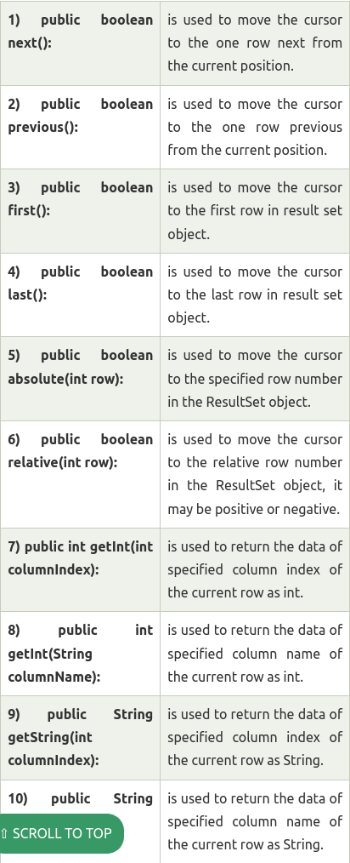

Example of Scrollable ResultSet

Let’s see the simple example of ResultSet interface to retrieve the data of 3rd row.
import java.sql.*;
class FetchRecord{
public static void main(String args[])throws Exception{

Class.forName("oracle.jdbc.driver.OracleDriver");
Connection con=DriverManager.getConnection("jdbc:oracle:thin:@localhost:1521:xe","system","oracle");
Statement stmt=con.createStatement(ResultSet.TYPE_SCROLL_SENSITIVE,ResultSet.CONCUR_UPDATABLE);
ResultSet rs=stmt.executeQuery("select * from emp765");

//getting the record of 3rd row
rs.absolute(3);
System.out.println(rs.getString(1)+" "+rs.getString(2)+" "+rs.getString(3));

con.close();
}}

PreparedStatement interface

The PreparedStatement interface is a subinterface of Statement. It is used to execute parameterized query.

Let's see the example of parameterized query:

String sql="insert into emp values(?,?,?)";

As you can see, we are passing parameter (?) for the values. Its value will be set by calling the setter methods of PreparedStatement.
Why use PreparedStatement?

Improves performance: The performance of the application will be faster if you use PreparedStatement interface because query is compiled only once.

How to get the instance of PreparedStatement?

The prepareStatement() method of Connection interface is used to return the object of PreparedStatement. Syntax:

public PreparedStatement prepareStatement(String query)throws SQLException{}

Methods of PreparedStatement interface

The important methods of PreparedStatement interface are given below:

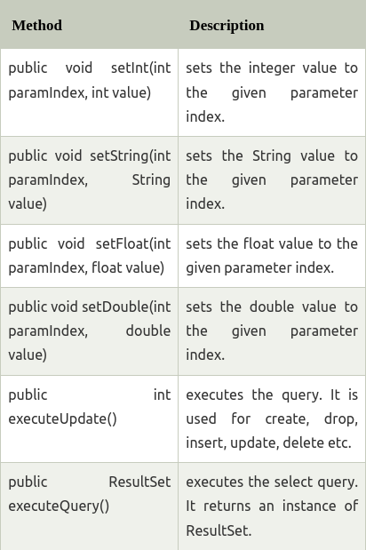

Example of PreparedStatement interface that inserts the record

First of all create table as given below:

create table emp(id number(10),name varchar2(50));

Now insert records in this table by the code given below:

import java.sql.*;
class InsertPrepared{
public static void main(String args[]){
try{
Class.forName("oracle.jdbc.driver.OracleDriver");

Connection con=DriverManager.getConnection("jdbc:oracle:thin:@localhost:1521:xe","system","oracle");

PreparedStatement stmt=con.prepareStatement("insert into Emp values(?,?)");
stmt.setInt(1,101);//1 specifies the first parameter in the query
stmt.setString(2,"Ratan");

int i=stmt.executeUpdate();
System.out.println(i+" records inserted");

con.close();

}catch(Exception e){ System.out.println(e);}

}
}

Example of PreparedStatement interface that updates the record

PreparedStatement stmt=con.prepareStatement("update emp set name=? where id=?");
stmt.setString(1,"Sonoo");//1 specifies the first parameter in the query i.e. name
stmt.setInt(2,101);

int i=stmt.executeUpdate();
System.out.println(i+" records updated");

Example of PreparedStatement interface that deletes the record

PreparedStatement stmt=con.prepareStatement("delete from emp where id=?");
stmt.setInt(1,101);

int i=stmt.executeUpdate();
System.out.println(i+" records deleted");

Example of PreparedStatement interface that retrieve the records of a table

PreparedStatement stmt=con.prepareStatement("select * from emp");
ResultSet rs=stmt.executeQuery();
while(rs.next()){
System.out.println(rs.getInt(1)+" "+rs.getString(2));
}

Example of PreparedStatement to insert records until user press n

import java.sql.*;
import java.io.*;
class RS{
public static void main(String args[])throws Exception{
Class.forName("oracle.jdbc.driver.OracleDriver");
Connection con=DriverManager.getConnection("jdbc:oracle:thin:@localhost:1521:xe","system","oracle");

PreparedStatement ps=con.prepareStatement("insert into emp130 values(?,?,?)");

BufferedReader br=new BufferedReader(new InputStreamReader(System.in));

do{
System.out.println("enter id:");
int id=Integer.parseInt(br.readLine());
System.out.println("enter name:");
String name=br.readLine();
System.out.println("enter salary:");
float salary=Float.parseFloat(br.readLine());

ps.setInt(1,id);
ps.setString(2,name);
ps.setFloat(3,salary);
int i=ps.executeUpdate();
System.out.println(i+" records affected");

System.out.println("Do you want to continue: y/n");
String s=br.readLine();
if(s.startsWith("n")){
break;
}
}while(true);

con.close();
}}

Java ResultSetMetaData Interface

The metadata means data about data i.e. we can get further information from the data.

If you have to get metadata of a table like total number of column, column name, column type etc. , ResultSetMetaData interface is useful because it provides methods to get metadata from the ResultSet object.
Commonly used methods of ResultSetMetaData interface

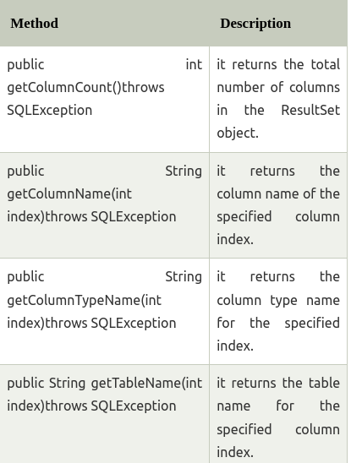

How to get the object of ResultSetMetaData:
The getMetaData() method of ResultSet interface returns the object of ResultSetMetaData. Syntax:

public ResultSetMetaData getMetaData()throws SQLException

Example of ResultSetMetaData interface :

import java.sql.*;
class Rsmd{
public static void main(String args[]){
try{
Class.forName("oracle.jdbc.driver.OracleDriver");
Connection con=DriverManager.getConnection(
"jdbc:oracle:thin:@localhost:1521:xe","system","oracle");

PreparedStatement ps=con.prepareStatement("select * from emp");
ResultSet rs=ps.executeQuery();
ResultSetMetaData rsmd=rs.getMetaData();

System.out.println("Total columns: "+rsmd.getColumnCount());
System.out.println("Column Name of 1st column: "+rsmd.getColumnName(1));
System.out.println("Column Type Name of 1st column: "+rsmd.getColumnTypeName(1));

con.close();
}catch(Exception e){ System.out.println(e);}
}
}

